Java Fundamentals
Introduction 2
Java Classification 2
J2SE / JAVA SE 2
J2EE/JAVA EE 3
J2ME / JAVA ME 3
Java History 4
Content of Core Java 5
Introduction 6
Java History 7
Simple PL 7
Arch Neutral PL 7
Tight Coded 7
Differences between Java and others [C and C++] 8
Java Features 15
Java Naming Conventions 18
Java Programming Format 19
Comment Section 20
Package Section 20
Import Section 21
Classes / interfaces Section 23
Main Class Section 23
Steps to prepare First Java Application 23
Write Java program 24
Compile Java File 24
Execute Java Application 26
Language Fundamentals 26
Tokens 27
Identifiers 27
Literals 28
Keywords and Reserved Words 29
Operators: 29
Data Types 30
Primitive Data types / Primary Data Types 31
User defined Data Types / Secondary Data Types: 31
Type Casting 33
Primitive Data Types Type Casting 34
Java Statements 43
Conditional Statements 44
Switch 48
Iterative Statements 51
Transfer Statements 52
Arrays 58
Single Dimensional Arrays 58
Multi-Dimensional Arrays 58

Introduction

Java Classification

J2SE / JAVA SE
- Java 2 Standard Edition
- It will cover only the fundamentals of the Java programming language.
- Standalone Applications.
- If we design and execute any application without using client-server arch or without distributing application logic over multiple machines, then that application is called as “Standalone Application”.
- EX: Calculator, paint, notepad, editplus, notepad++
- 5% of the applications are standalone applications
- Its dependency level is 1000%.
- Java is a dependent Programming language for
1. J2EE
2. Android
3. Selenium

J2EE/JAVA EE
- Java 2 Enterprise Edition
- It will cover Server-side programming
- Distributed Applications / Enterprise Applications
- If we design and execute any application on the basis of Client-Server arch or by distributing application logic over multiple machines, then that application is called a Distributed application or Enterprise application.

J2ME / JAVA ME
- Java 2 Micro Edition
- Micro programming
- Mobile Based Applications
- If we design and execute any application on the basis of Mobile H/W system then that application is called as Mobile Based Application.
- Calculator in Mobile phones, Calender mobile phones,...
- Mobile application are having very good demand in out side market, but, no demand is available for J2ME.

Java History
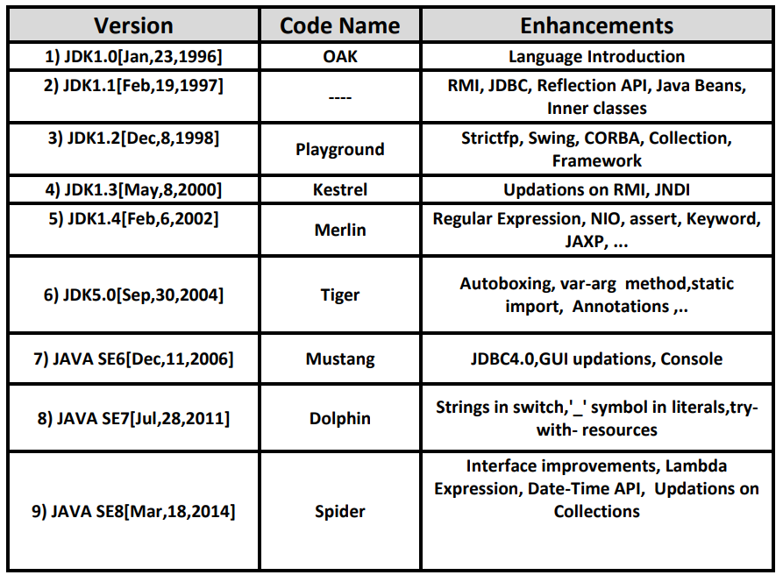
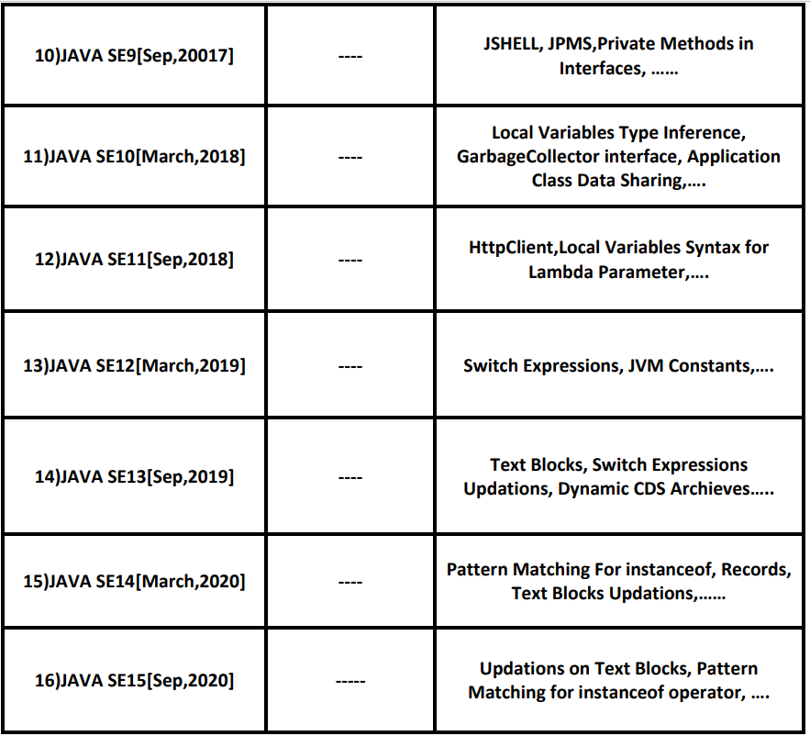

Content of Core Java
- Introduction
- Steps to Prepare First Java Application
- Language Fundamentals
- OOPs ************** 100
- Wrapper Classes
- String Manipulations ***** 10
- Inner Classes
- Exception Handling ***********50
- Multi-Threading *********** 50
- Iostreams ****5
- Networking
- RMI
- Arrays
- Collection Framework*************80
- Generics
- Reflection API
- Annotations ******10
- JVM Arch
- Garbage Collection
- I18N[Internationalization]
- GUI
- Regular Expressions
- Java 8 Features**********50
- JAVA 9 Features **** 5
- —--
—--
—-
35. Java 19 Version Features

Introduction
- Java History
- Differences between Java and Others [C and C++]
- Java Features
- Java Naming Conventions
- Java Programming Format

Java History
- 1991, SUN Microsystems had a requirement to prepare new PL , by using new PL SUN Microsystems wants prepare software’s for electronic consumer goods like Remote Controllers, Cable TV Switch Boxes,.
- 30 members Team → James Gosling and Patrick Naughtan
- Green Team
- PL —---> 1. Simple PL
2. Tight Coded PL
3. Arch Neutral PL

Simple PL
- Less execution time —-> More Performance
- Less Memory Consumption –→ Less cost for product
- Less Power consumption → Less Maintenance cost

Arch Neutral PL
- It must execute its functionalities in all the H/W systems.

Tight Coded
→ In C PL —-> Stack
- PUSH —---> 20 LOC
- POP —-----> 20 LOC
- PEEK —----> 20 LOC
—--------------------------
Total —---> 60 LOC
IN JAVA:
Stack s = new Stack();
s.push(“AAA”);
s.pop();
s.peek();
—----------------------------
Total —---> 4 LOC
- 1996, JAN, 27th, —-> JAVA 1.0 —> JDK1.0

Differences between Java and others [C and C++]

C and C++ are Static Programming Languages, but Java is a dynamic Programming language
- In Java applications memory will be allocated for the primitive data types at runtime only.

Pre-Processor is required in C and C++, but Pre-Processor is not required in JAVA
- In Java, the complete predefined library was provided in the form of classes and interfaces in packages.
- EX:
java.io
java.util
java.sql
- In Java applications, if we want to use a predefined library then we have to import the required packages, to import the packages we have to use the “import” statement.
- EX:
import java.io.*;
import java.util.*;
import java.sql.*;
When we compile java application, compiler will perform the following actions.
- Compiler will recognize all the import statements; compiler will take the provided package names.
- Compiler will check whether these packages exist or not in java software.
- If the specified packages do not exist, then compiler will raise an error.
- If the specified packages existed, then compiler will not raise any error and at the same time compiler will not load any package content to the memory.
Note: In Java, at runtime, JVM will load the required library to the memory, this type of loading is called as “Dynamic Loading”
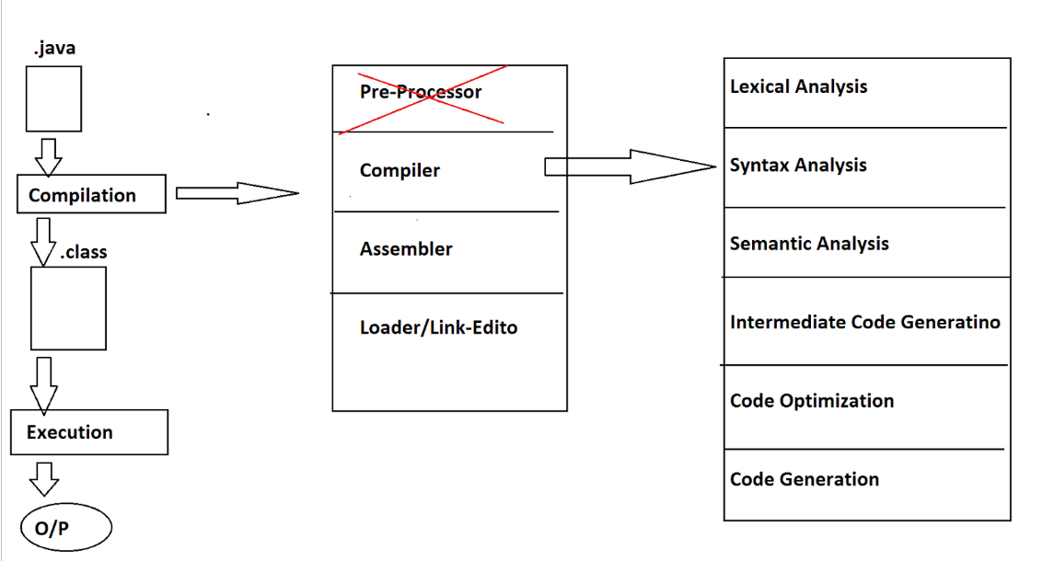

C and C++ are platform Dependent Programming languages, but Java is a platform independent programming Language
- If any Programming language allows its applications to perform compilation on one Operating system and execution is on another operating system, then that Programming Language Platform Independent Programming Language.
- EX: JAVA
- If we compile a Java application on Windows Operating System then the compiler will generate .class file, it contains bytecode, it is not directly executable code, it is an intermediate code and it does not have any Operating System representations.
- If we want to execute bytecode on any of the Operating Systems, then that neutral bytecode must be converted to the respective Operating System representations.
- In the above context, SUN Microsystems has provided the required converters in order to execute java applications in multiple Operating systems that is to make java as platform independent Programming language.
- In the above context, SUN Microsystems has provided all converters along with the Execution process in a single component inside Java software that is “JVM”.
- Java is a platform independent Programming language because of JVMs, but, JVM is Platform Dependent.
- Note: Not only JVM, but the complete Java Software is also platform Dependent.

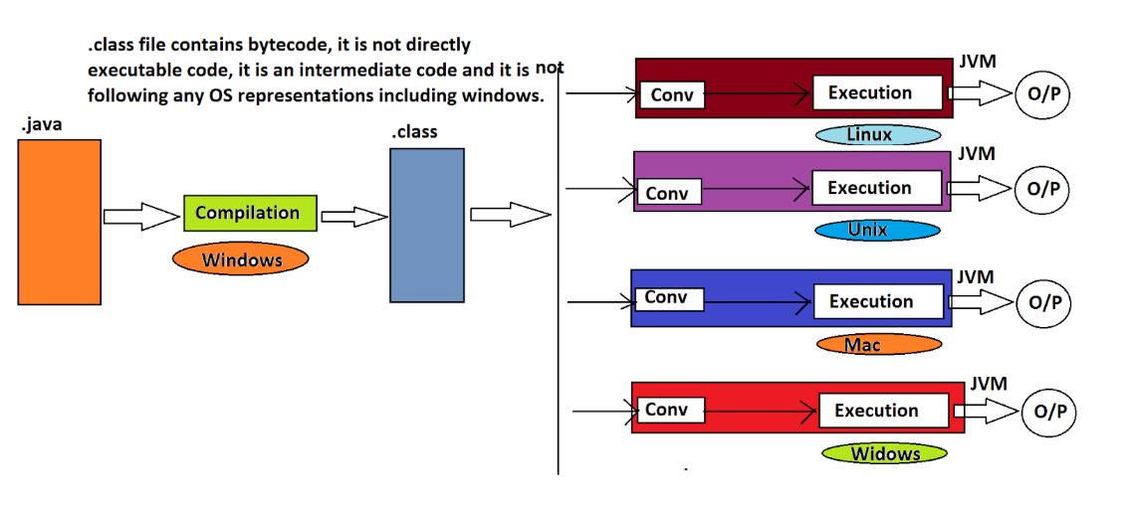

Reference variables
- Reference variables can refer to a block of memory [Object] by storing Object reference value.
- Object reference value is the hexadecimal form of hash code provided by JVM, where Hash code is a unique identity for each Object provided by heap manager in the form of an integer value to JVM.
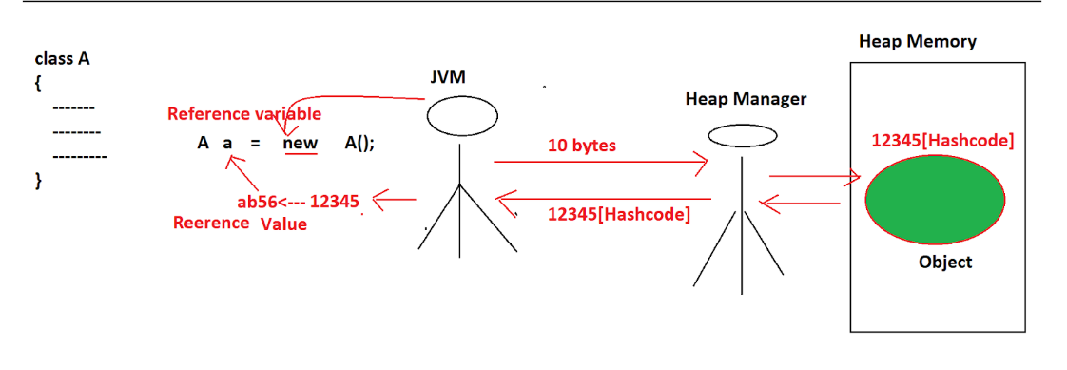

Multiple Inheritance is not possible in Java
- If any PL represents data in the form of Objects as per Object Oriented Features, then that PL is called as an Object-Oriented Programming language.
- There are seven no of Object-oriented Features to represent data in Object Oriented Programming languages.
- Class
- Object
- Encapsulation
- Abstraction
- Inheritance
- Polymorphism
- Message Passing
- In Object orientation, all the real-world entities are declared as classes.
EX:
class Student{
}
class Product{
}
class Customer{
}
Inheritance:
- It is a relation between classes; it will provide variables and methods from one class [Super class] to another class [Sub class] in order to improve Code Reusability.
- The main intention of Inheritance is to provide Code Reusability.
- Initially there are two types of Inheritances.
- Single Inheritance
- Multiple Inheritance
- Based on the above inheritances, there are three more inheritances.
- Multi-Level Inheritance.
- Hierarchical Inheritance.
- Hybrid Inheritance
- Single Inheritance: It is a relation between classes; it will provide variables and methods from only one super class to one or more no of sub classes.
Java does support Single Inheritance.
- Multiple Inheritance: It is a relation between classes; it will provide variables and methods from more than one superclass to one or more no of sub classes.
Java does not support Multiple Inheritance.

- In case of Multiple inheritance, if we declare same variables and same methods with different values and with different implementations in more than one superclass and if we access that variables and methods in the respective sub class then it will be a confusion state for compiler and JVM that to get variable values and methods implementations from which super class.
- Java is a simple programming language; it must not allow the confusion-oriented features like Multiple Inheritance.
- To restrict Multiple inheritance, JAVA has defined ‘extends’ keyword in such a way that to allow only one super class name, not to allow more than one superclass name in subclass declaration.

class A{
}
class B extends A{
}
Status: Valid
EX:
class A{
}
class B{
}
class C extends A,B{
}
Status: Invalid
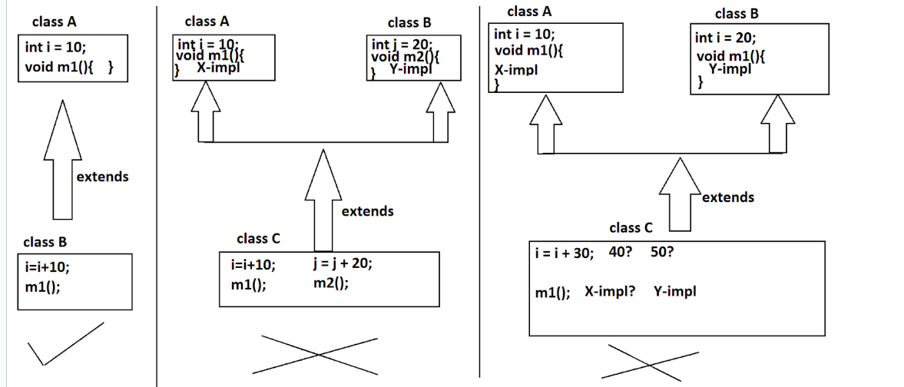

Destructors existed in C++, but Destructors do not exist in Java
- In Object oriented programming languages, it is a minimum convention to represent data in the form of Objects.
- In Object oriented programming languages, to manage the data in the form of objects, first we must create the objects, at least at the end of the applications we must destroy the objects.
- Due to the above reasons, we must perform the following two operations in Object oriented programming languages.
- Creating Objects
- Destroying Objects
- To create objects, all the Object-oriented programming languages are providing a separate feature called “Constructors”.
- To destroy objects, almost all the Object-oriented programming languages are providing a separate feature called as “Destructors”.
- In Java, developers are responsible for only creating objects, not responsible for destroying objects, because, in Java, there is an internal component to destroy objects automatically, here the component which is provided by JAVA to destroy objects is called as “Garbage Collector”.

Operator Overloading is not possible in Java
- Java does not support operator overloading, because,
- Operator overloading is a rarely used feature in application development.
- It is a bit of a confusion-oriented feature when we define more no of operators with more no of functionalities.

- Note: As per the java internal requirement, JAVA made some of the predefined operators as overloaded operators with fixed functionalities, but, JAVA has not provided any environment to define operator overloading explicitly at developers level.

EX:
int i = 10;
int j = 20;
int k = i + j; → here + is for Arithmetic Addition.
System.out.prntln(k); → 30

String str1 = “abc”;
String str2 = “def”;
String str3 = str1 + str2; → Here + is for String concatenation.
System.out.println(str3); → abcdef

C and C++ are following call By value and call by reference parameter passing mechanisms, but Java is following only call by value parameter passing mechanism
- In Java applications, if we pass reference variable as parameter to the methods then the parameter passing mechanism is “Call By Value” only, not Call By Reference, because, in Java applications, reference variables are able to store object reference values, not address locations, where Object reference value is hexa-decimal form of Hashcode, where Hashcode is an unique identity provided to the each and every abject in the form of an integer value.

In C and C++ , integers will take 2 bytes of memory, characters will take 1 byte of memory, but in Java, integers will take 4 bytes of memory, characters will take 2 bytes of memory
- In the case of Java, memory allocation for the primitive data types is fixed irrespective of the operating systems which we used.
byte —----------> 1 byte
short —---------> 2 bytes
int —------------> 4 bytes
long —-----------> 8 bytes
float —----------> 4 bytes
double —---------> 8 bytes
char —-----------> 2 bytes
boolean —--------> 1 bit
- In the case of JAVA, all the characters are represented in the form of UNICODEs, to store any UNICODE value 2 bytes of memory is required
- UNICODE is one of the character representations, it can represent all the alphabet from all the natural languages like English, Hindi, Italian, Japanese....With these representations, it is able to provide very good Internationalization support in Java applications.

Internationalization
- Preparing applications with the local conventions of the users / Customers is called internationalization.
- Java is providing a very good Internationalization Service due to the UNICODE representations only.

Java Features
- To describe the nature of the Java programming language, JAVA has provided a set of features called Java features.
- Simple
- Object Oriented
- Platform Independent
- Arch Neutral
- Portable
- Robust
- Dynamic
- Secure
- Distributed
- Multi-Threaded
- Interpretive
- High Performance

Simple
- Java applications will take less memory and less execution time.
- Java has removed all the confusion-oriented features like Pointers, Multiple Inheritance...
- Java is using all the simplified syntaxes from C and C++.

Object Oriented
- Java is an Object-oriented Programming language, because java allows to represent data in the form of Objects as per the Object-oriented features.

Platform Independent
- Java is a platform independent programming language, because java allows its applications to perform compilation on one operating system and execution on another operating system.

Arch Neutral
- Java is an Arch neutral Programming language, because Java allows its applications to compile on one H/W system and execute on another H/W system.

Portable
- Java is a portable programming language, because Java allows its applications to execute in multiple Operating systems and in multiple H/W systems without changing anything in the Java application.
- Nowadays Java applications are used in many machines like Computers, Mobiles, Parking meters, sensors, signalling systems, ..........
- Java is used to prepare all the types of applications like standalone applications, Web applications, Distributed applications, database related applications, some other products like selenium , salesforce, SAP ,.

Robust
- Java has a very good memory management system in the form of Heap memory management system, it is a dynamic memory management system, it allocates and deallocates memory for the objects at runtime.
- Java has very good exception handling mechanisms, because java has a very good, predefined library to represent and handle almost all the exceptions which are coming frequently in java applications.

Dynamic
- Java is a dynamic programming language, because Java allows memory allocation for the data at runtime.

Secure
- Java is very good at implicit security, because Java has a Security manager to provide implicit security with the help of Byte code verifier inside JVM.
- Java has very good web security, because Java has provided a separate middleware service in the form of JAAS [Java Authentication And Authorization Service] to provide web security in web applications.
- Java has very good network security, because Java has provided very good, predefined implementations for almost all the network security algorithms as part of its security module.

Distributed
Java is used to prepare two types of applications.
- Standalone Applications
- Distributed Applications
If we design and execute any application without using Client-Server arch or without distributing application logic over multiple machines, then that Programming language is called “Standalone Applications”. To prepare Standalone Applications J2SE libraries are sufficient.
If we design and execute any application on the basis of Client-Server arch or by distributing application logic over multiple machines, then that Programming language is called as Distributed application.
To prepare Distributed applications, JAVA has provided a separate module that is J2EE module.

Multi-Threaded
Thread is a flow of execution to perform a particular task.
There are two thread models
- Single Thread Model
- Multi Thread Model
Single Thread Model:
- It Allows only one thread.
- It follows sequential execution.
- It takes more execution time
- Provides Less performance.

Multi Thread Model:
- It allows more than one thread at a time.
- It follows parallel execution.
- It takes less execution time
- It provides more performance
Java is following the Multi Thread Model to execute its applications. Java is able to provide a very good environment to create and execute more than one thread at a time. Due to this reason JAVA is Multithreaded Programming Language.

Interpretive
- Java is both Compilative and interpretive programming language. To convert a program from Source code to bytecode and to check developers mistakes we need compilation and to execute java applications we need an interpreter inside JVM.

High Performance
Java is high performance programming language, because,
- Its rich set of features like Portable, Dynamic, Secure, Multithreaded, Distributed, ......
- Due to the components like JIT Compiler inside JVM to boost up JVM Performance.

Java Naming Conventions
- Java is a case sensitive Programming Language, where in java applications there is a separate recognition for lower case letters and uppercase letters.
- abc != ABC
To use lower case letters and upper-case letters separately we must use the following conventions.
- All Java classes names, abstract classes names, interfaces names must be started with an uppercase letter and the subsequent symbols must also be uppercase letters.
EX: String , StringBuffer, InputStreamReader
WindowAdapter, GenericServlet
Serializable, Externalizable, Comparable
- All Java variable names must be started with lower case letters, but the subsequent symbols must be upper case letters.
EX: in, out, err
pageContext, bodyContent
tempEmpAddr
- All Java method names must be started with lower case letters, but the subsequent symbols must be upper case letters.
EX: concat()
forName()
getInputStream()
- All java package names must be provided in lower case letters.
EX: java.io
java.awt.event
javax.servlet.jsp.tagext
- All java constant variables must be provided in Upper case letters.
EX: MIN_PRIORITY
MAX_PRIORITY
NORM_PRIORITY
Note: All the above conventions are mandatory while writing predefined libraries, the above conventions are optional while writing user defined libraries, but suggestible.

Java Programming Format
- To prepare a basic java program we have to use the following phases.
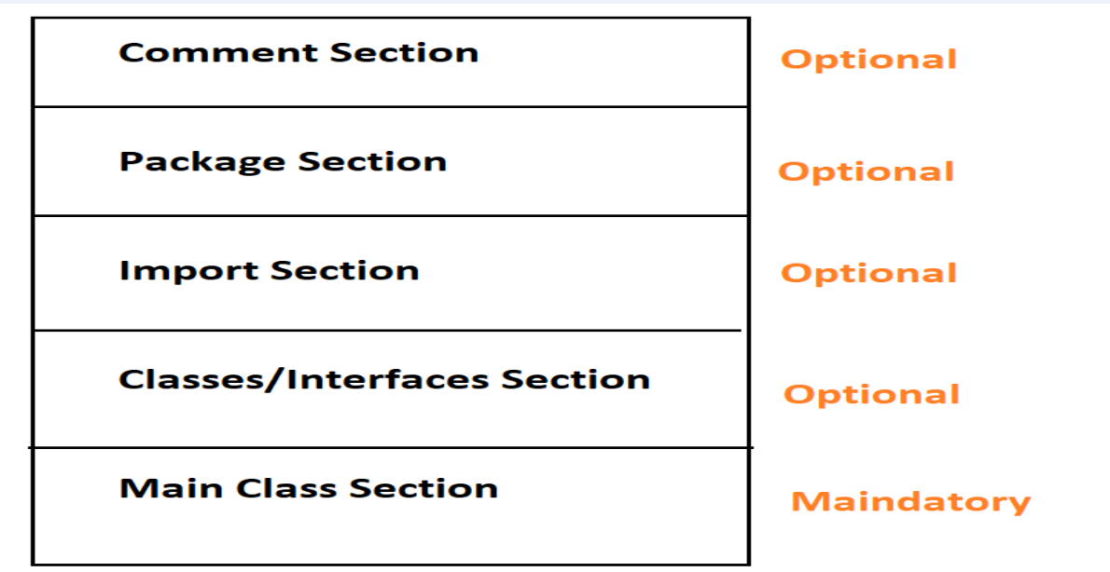

Comment Section
- Comment is a non-executable part of a Java program.
- In Java, there are three types of comments.
- Single Line comment
- Multi Line Comment
- Documentation Comment

Package Section
- Package is the collection of related classes and interfaces as a single unit.
- Package is a Folder containing .class files representing related classes and interfaces.
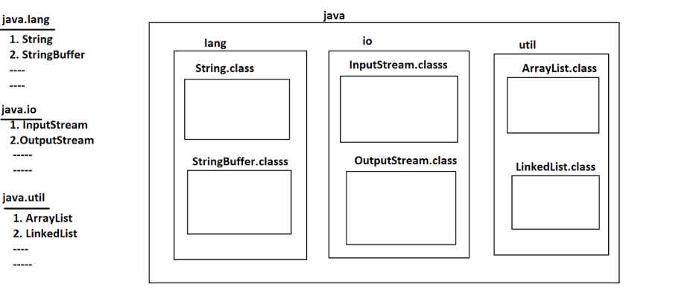
- Advantages:
- Modularity
- Abstraction
- Security
- Shareability
- Reusability
- Types:
- Predefined packages
- User Defined packages
- To provide uniqueness in package names JAVA has provided a suggestion to the developers to include our company domain name in reverse in package name.
package com.durgasoft.icici.transactions.deposit;
com.durgasoft —---> Company Domain name in reverse.
icici —---------------> Client name / project name
transactions —------> Module name
deposit —------------> Sub module name

Import Section
- The main purpose of the import statement is to make available all classes and interfaces of a particular package in to the present java file.
import packageName.*;
- It is able to import all classes and interfaces from the specified package in to the present java file.
import java.io.*;
import java.util.*;
import java.sql.*;
import packageName.memberName;
- It can import only the specified class or interface from the specified package into the present java file.
import java.io.BufferedReader;
import java.util.ArrayList;
import java.sql.Connection;

Q) Is it possible to use classes and interfaces of a particular package without importing the respective package?
- Yes, it is possible to use classes and interfaces of a particular package without importing the respective package, but, we must use the “Fully Qualified Name” of the respective class or interface.
- If we provide classes and interfaces along with their respective package name is called a “Fully Qualified Name”.
java.io.BufferedReader
java.util.ArrayList
java.sql.Connection
- In Java applications it is always suggestible to use import statements instead of fully qualified names, here in import statements it is always suggestible to use import statements with out * notation, that is, individual classes or interfaces importing is suggestible.

EX: A Java program without import statement
java.io.BufferedReader br = new java.io.BufferedReader(new java.io.InputStreamReader(System.in));

EX: A Java program with import statement with * notation:
import java.io.*;
BufferedReader br = new BufferedReader(new InputStreamReader(System.in));

EX: A Java program with import statement with out * notation:
import java.io.BufferedReader;
import java.io.InputStreamReader;
BufferedReader br = new BufferedReader(new InputStreamReader(System.in));

Classes / interfaces Section
- The main intention of class or interface is to represent all real world entities in Java applications.
- EX: Student, Employe, Product, Customer, Account,....
- In Java applications we are able to write any no of classes and interfaces as per the application requirement.

Main Class Section
- If any class includes the main() method then that class is called “Main Class”.
- The main intention of the main() method is,
- To manage the application logic which is executed by JVM automatically we need the main() method.
- To define starting point and ending point to the application execution we need the main() method.
Syntax:
class Test{
public static void main(String[] args){
—-Application Logic—----
}
}

Steps to prepare First Java Application
- Download and install Java Software.
- Download and install Java Editor
- Open Java editor and Write Java program
- Save Java File
- Compile Java file
- Execute Java Application

Write Java program
- To write java applications at the basic level we must use the following programming elements.
- Declare a class
- Declare main() method
- Inside the main() method write application logic.
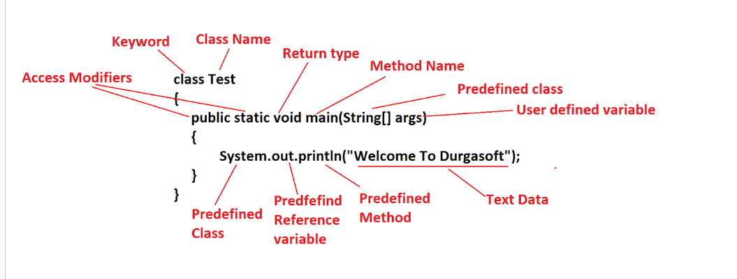
To save Java files, we must use the following rules and regulations.
- If the present java file contains public class or public abstract class or public interface then the respective java file name must be the public class name or public abstract class name or public interface name, if we violate this rule then the compiler will raise an error.
- If no element [Class / abstract class / interface] is public in the present java file then it is possible to save a java file with any name like abc.java or xyz.java, in this context, java has given a suggestion like to save java file with main class name.

Q) Is it possible to provide more than one public class in a Single Java file?
- No, it is not possible to provide more than one public class in single java file, as per the java rules and regulations if any class is public in java file then we must save that java file with the public class name , in the case if we provide more than one class as public then we must save that java file with more than one name , it is not possible in all the operating systems.

Compile Java File
- The main intention to perform compilation is
- To translate a java program from Source code to bytecode.
- To check developers' mistakes before execution.
To perform compilation, Java software has provided a command that is “javac”.
- Generating the number of .class files is not depending on the number of java files which we compiled, it is completely dependending on the following elements which we provided in java file.
- Number classes
- Number of abstract classes
- Number of interfaces
- Numbers of enums
- Number of inner classes
EX:
Test.java
enum E{// E.class
}
interface I{// I.class
}
abstract class A{// A.class
}
class B{// B.class
class C{// B$C.class
}
}
class Test{// Test.class
public static void main(String[] args){
System.out.println("Welcome To Java");
}
}

Execute Java Application
- To execute a Java program, Java has provided a predefined command in the form of “java”.
- When the Operating System executed java command, automatically JVM software will be activated and JVM will perform the following actions
- JVM will take main class name from the command prompt which we provided along with java command
- JVM will load the main class bytecode to the memory by using “Class Loaders” internally.
- After loading main class bytecode to the memory , JVM will search for the
main() method in the loaded main class
- If main method is not identified in the loaded main class then JVM will provide
the following Exception /Error
Java6: java.lang.NoSuchMethodError: main
Java7: Error: Main method not found in class Test, please define the main
- If the main() method is existed in the loaded main class then JVM will create a
thread to execute main() method named “Main Thread”.
- Main Thread will start application execution right from starting point of the
main() method to the ending point of the main() method.
- When Main Thread reaches the ending point of main() method , Main Thread will come to Dead State.
- When Main Thread is in Dead state, JVM will stop all the internal services
which are assigned to the Java program execution and JVM will go to Shut down mode.
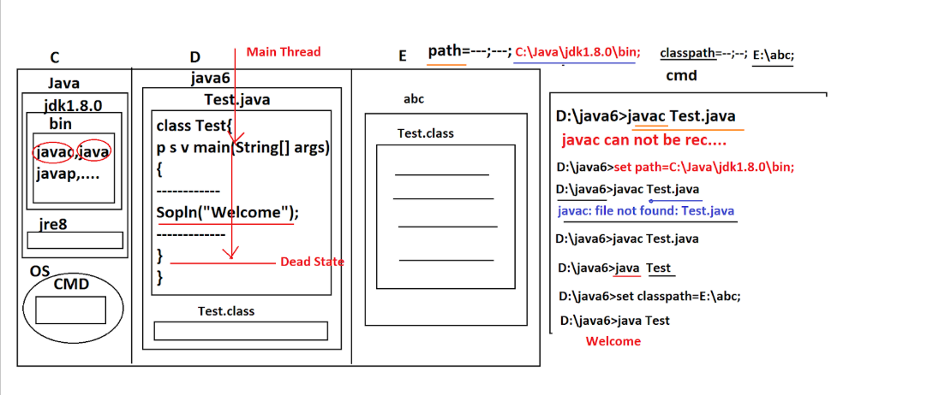

Language Fundamentals
- Tokens
- Data Types
- Type Casting
- Java Statements
- Arrays

Tokens
- Lexeme: The individual logical unit in Java programming is called “Lexeme”.
- Token: The collection of Lexemes comes under a particular group called
“Token”.
EX:
int a = b + c * d;
No of Lexemes: int, a, =, b, +, c, *, d, ; : 9 Lexemes
int —-----> Data Type
a, b, c , d —----> Variables / Identifiers
=, +, * —------> Operators
; —-----------> Special Symbol / Terminator
No of Tokens : 4 types of Tokens

To prepare Java applications, JAVA has provided the following Tokens.
- Identifiers
- Literals
- Keywords / Reserved Words
- Operators

Identifiers
- Identifier is a name assigned to the programming elements like variables , methods, constructors, classes, interfaces, packages,.....
- Java has provided the following rules and regulations to give names to the programming elements.
- All Java identifiers must not be started with a number, identifiers may start with an alphabet, _ symbol , $ symbol, but the subsequent symbols may be a number, an alphabet, _ symbol, $ symbol.
- Identifiers do not have spaces in the middle.
- In Java applications, all operators are not allowed in the identifiers.
- All Java identifiers are not allowing all special symbols except _ symbol and $ symbol.
- All Java identifiers are not allowing keywords
- All Java identifiers are not allowing primitive data types.
- All Java identifiers are allowing predefined classes , abstract classes and interfaces names.

Literals
- Literal is a constant assigned to the variables.
int a = 10;
int —---> Data Type
a —-----> Variable/Identifier
= —-----> Operator
10 —----> Constant[Literal]
; —-------> Terminator / Special Symbol

- To prepare Java applications, JAVA has provided the following types of Literals.
- Integral / Integer Literals
byte, short, int, long —--> 10, 20, 34,......
char —-> ‘a’, ‘b’, ‘\t’, ‘\n’
- Floating point Literals
float —----> 22.22f, 456.234f, 876.234F,....
Double —--> 222.22, 345.345d, 567.345D,...
- Boolean Literals:
boolean —-> true, false
4. String Literals:
String —--> “abc”, “xyz”, “12334”, “true”, “22.22f”, “234.345”,
Note: Only String data type is able to represent all the types of data including numbers, characters,......
Note: To improve Readability in literals JAVA 1.7 version has provided a flexibility to include ‘_’ symbols in the literals.
EX:
- Up to JAVA6: double d = 123456789.2345;
- From JAVA7: double d = 12_34_56_789.2345;
- When we compile the above instruction, Compiler will remove all the ’_’ symbols from the number, Compiler and JVM will process that number without ‘_’ symbols and JVM will provide output without ‘_’ symbols only.

Number Systems in Java
- In all programming languaGES , to represent numbers we have to follow some standards they are “Number Systems”.
- In general, there are four types of Number Systems.
- Binary Number System
- Octal Number System
- Decimal Number System
- Hexa-Decimal Number System

- All the number Systems are allowed in Java, but the default number system is “Decimal Number System”.

Keywords and Reserved Words
- If any predefined word has word recognition and internal functionality then that predefined word is called “Keyword”.
- If any predefined word has only word recognition but does not have internal functionality then that predefined word is called “Reserved Word”.
- EX: goto, const

Operators:
- Operator is a symbol, it is able to perform a particular operation over the provided operands.
- Java has provided the following list of operators to perform operations.
- Arithmetic Operators
  - +, -, *, /, %, ++,--
- Assignment Operators:
  - =, +=, -=, *=,/=,%=
- Comparison Operators:
  - ==, !=, <, <=, >, >=
- Logical Boolean Operators:
  - &, |, ^,....
- Logical bitwise Operators:
  - &, |, ^, <<, >>,...
- Ternary Operator:
  - Expr1?Expr2:Expr3;
- Short-Circuit Operators:
  - &&, ||

Q) What is the difference between |[Single OR] and ||[Double OR] ?
- In the case of ||[Double OR], if the first operand value is true then JVM will use Shortcut of OR operator and JVM will find the overall result of OR operator true without evaluating Second operand.
- In the case of | [Single OR], if the first operand value is true even JVM will not go for the shortcut, JVM will evaluate second operand value and JVM will find the overall OR operator result on the basis of both the operand values.

Q)What is the difference between &[Single AND] and &&[Double AND] ?
- In the case of &&[Double AND], if the first operand value is false then JVM will use Shortcut of AND operator and JVM will find the overall result of AND operator false without evaluating Second operand.
- In the case of & [Single AND], if the first operand value is false even JVM will not go for the shortcut, JVM will evaluate second operand value and JVM will find the overall AND operator result on the basis of both the operand values.

Data Types
JAVA has provided the following Data Types.

Primitive Data types / Primary Data Types

Numeric Data Types:
- Integral / Integer Data Types:
byte —-----------> 1 byte —---> 0
short —---------> 2 bytes—---> 0
int —------------> 4 bytes—---> 0
long—-----------> 8 bytes—---> 0L

Non-Integral Data Types:
float—-----------> 4 bytes—-----> 0.0f
double —--------> 8 bytes—------> 0.0

Non-Numeric Data Types:
char—-----------------> 2 bytes —-----> ‘ ‘[Single space]
boolean—-------------> 1 bit —---------> false

User defined Data Types / Secondary Data Types:
- EX: All Arrays, All classes, abstract classes, interfaces,.....
- No fixed memory sizes for the user defined data types, memory sizes are depending on the volume of data which we represented.
- Note: The default value for all the user defined variables is ‘null’.
  - EX: String str; // where str value is null

- In Java applications, to find range values of the data types we must use the following formula.
n-1 n-1
-2 to 2 - 1
- Where ‘n’ is the number of bits of the data type.
EX: byte
Size: 1 byte = 8 bits
8-1 8-1
-2 to 2 - 1
7 7
-2 to 2 - 1
-128 to 128 - 1
-128 to 127
- The above formula is applicable for Integral data Types only, not for all the remaining data types.
- To represent Min Value and Max Value of each data type , JAVA has provided the following constant variables from all the wrapper classes.
MIN_VALUE
MAX_VALUE
- Note: Java has provided a separate class representation for each and every primitive data type , where the class which is representing the primitive data type is called “Wrapper Classes”
byte —--------------> java.lang.Byte
short—--------------> java.lang.Short
int—-----------------> java.lang.Integer
long—---------------> java.lang.Long
float—--------------> java.lang.Float
double—------------> java.lang.Double
char—---------------> java.lang.Character
boolean—------------> java.lang.Boolean
- Note: MIN_VALUE and MAX_VALUE constants are available in almost all the wrapper classes except Boolean, these constants exist in Character class but they are able to provide space is min value and ? is max value.
class Test{
public static void main(String[] args){
System.out.println(Byte.MIN_VALUE+" ----> "+Byte.MAX_VALUE);
System.out.println(Short.MIN_VALUE+" ---> "+Short.MAX_VALUE);
System.out.println(Integer.MIN_VALUE+" –> "+Integer.MAX_VALUE);
System.out.println(Long.MIN_VALUE+" ----> "+Long.MAX_VALUE);
System.out.println(Float.MIN_VALUE+" ----> "+Float.MAX_VALUE);
System.out.println(Double.MIN_VALUE+" ----> "+Double.MAX_VALUE);
System.out.println(Character.MIN_VALUE+" ----> "+Character.MAX_VALUE);
//System.out.println(Boolean.MIN_VALUE+" ----> "+Boolean.MAX_VALUE);
}
}

Output:
-128 ----> 127
-32768 ----> 32767
-2147483648 ----> 2147483647
-9223372036854775808 ----> 9223372036854775807
1.4E-45 ----> 3.4028235E38
4.9E-324 ----> 1.7976931348623157E308
----> ?

Type Casting
- The process of converting data from one data type to another data type is called “Type Casting”.
- The main advantage of Type Casting is “Flexibility” To represent Data.
- There are two types of Type Castings.
- Primitive Data Types Type Casting
- User Defined Data Types Type casting
- User Defined Data Types Type casting: The process of converting data from One user defined data type to another data type is called “User defined Data Types Type Casting”.
- To perform User defined data types of type casting we have to provide either extends [Inheritance] or implements [Polymorphism] relation between two user defined data types.

Primitive Data Types Type Casting
- The process of converting data from One primitive data type to another primitive data type is called “Primitive Data Types Type Casting”.
- There are two types of Primitive Data Types Type castings.
- Implicit Type casting / Widening
- Explicit Type Casting / Narrowing

Implicit Type Casting
- The process of converting data from lower data type to higher data type is called “Implicit Type casting”.
- To cover all possibilities of Implicit Type casting JAVA has provided a predefined chart.
1 2 4 8 4 8
byte—>short—>int—>long—>float—>double
^
|
char
- In Java applications, to perform implicit type casting we must assign lower data type variables to higher data type variables as per the above chart.
EX:
byte b = 10;
int i = b;
When we compile the above code [Assignment statement], the compiler will perform the following actions.
- Compiler will recognize right side variable data type and left side variable data type.
- Compiler will check whether the right-side variable data type is compatible with the left side variable data type or not.
- If the right-side variable data type is not compatible with left side variable data type, then compiler will raise any error like
JAVA7: Possible loss of Precision.
JAVA8: Incompatible Types: possible lossy conversion from xxx data type to yyy data type.
- If the right-side variable data type is compatible with the left side variable data type then Compiler will not raise any error, but at the same time Compiler will not perform any type casting.

- Note: In Java, all lower data types are compatible with higher data types, so we can assign lower data type variables to higher data type variables, all higher data types are not compatible with lower data types, so we are unable to assign higher data type variables to lower data type variables.

- Note: In Java, compiler is responsible for only Type checking, not responsible for Type casting, IN Java, only JVM is responsible for Type casting.
When we execute the above code [Assignment Statement] JVM will perform the following actions.
- JVM will convert the right-side variable data type to left side variable data type internally or implicitly [Implicit Type Casting].
- JVM will copy the value from the right variable to the left side variable.
Ex 1:
int i = 10;
byte b = i;
System.out.println(i+" "+b);
Status: Compilation Error
Ex 2:
byte b = 10;
int i = b;
System.out.println(b+" "+i);
Status: No Compilation Error
OP: 10 10
Ex 3:
byte b = 65;
char c = b;
System.out.println(b+" "+c);
Status: Compilation Error.
Ex 4:
char c = 'A';
short s = c;
System.out.println(c+" "+s);
Status: Compilation Error
- Reason: IN Implicit Type Casting, no conversions exist between char and byte, short and char due to the difference in internal data representations.
Ex 5:
char c = 'A';
int i = c;
System.out.println(c+" "+i);
Status: No Compilation Error
OP: A 65
Ex 6:
long l = 10;
float f = l;
System.out.println(l+" "+f);
Status: No Compilation Error
OP: 10 10.0

Ex 7:
float f = 22.22f;
long l = f;
System.out.println(l+" "+f);
Status: Compilation Error.

Ex 8:
byte b = 128;
System.out.println(b);
Status: Compilation Error.
Reason: 128 is more than the max value of byte, so 128 will come under integer.
Ex 9:
byte b1 = 60;
byte b2 = 70;
byte b = b1 + b2;
System.out.println(b);
Status: Compilation Error.
Ex 10:
byte b1 = 30;
byte b2 = 30;
byte b = b1 + b2;
System.out.println(b);
Status: Compilation Error
- Reason: If we add two data type variables then the resultant value may not be of the same data type, it may be of the next higher data type.
X, Y and Z are three primitive data types.
X + Y = Z
1. If X and Y belong to {byte, short, int} then Z should be int.
2. If either X or Y or both X and Y belong to {long, float, double} then Z should
be higher(X,Y).
EX:
byte + int = int
short + byte = int
short + int = int
int + int = int
byte + long = long
long + float = float
float + double = double
Ex 1:
byte b1 = 60;
byte b2 = 70;
int i = b1 + b2;
System.out.println(i);
Status: No Compilation Error
OP: 130
Ex 2:
float f = 22.22f;
long l = 10;
long l1 = f + l; //Error
float f=f+l; //No Error
System.out.println(l1);
Status: Compilation Error
Ex 3:
long l = 10;
double d = 23.345;
float f = l + d; //Because resultant data type should be greater than long and double ie double not float
System.out.println(f);
Status: Compilation Error.

Explicit Type Casting/ Narrowing
- The process of converting data from higher data type to lower data type is called “Explicit Type Casting”.
- To perform Explicit Type casting we have to use the following pattern.
P a = (Q) b;
- Where ‘b’ variable is of the higher data type than ‘a’ variable data type.
- Where Q is either same as P or lower than P.
EX:
int i = 10;
byte b = (byte)i;
If we compile the above assignment statement, then the compiler will perform the following actions.
- Compiler will recognize the cast operator provided data type and left side variable data type.
- Compiler will check whether the cast operator provided data type is compatible with the left side variable data type or not.
- If the cast operator provided data type is not compatible with the left side variable data type, then the compiler will raise an error.
- If the cast operator provided data type is compatible with the left side variable data type, then the compiler will not raise any error and the compiler will not perform any type casting.
Note: IN Java applications compiler is responsible for only Type checking ,compiler is not responsible for type casting.

When we execute the above assignment statement then JVM will perform the following actions.
- JVM will convert the data from right side variable data type to cast operator provided data type explicitly [Explicit Type Casting].
- JVM will copy the value from the right-side variable to the left side variable.
Ex 1:
class Test{
public static void main(String[] args){
int i = 10;
byte b = (byte)i; //byte<=byte True
System.out.println(i+" "+b);
}
}
Status: No Compilation Error
OP: 10 10
- Compiler->Type checking
- JVM->Type casting

Ex 2:
int i = 10;
short s = (byte)i; //byte<=short True
System.out.println(i+" "+s);
Status: No Compilation Error
OP: 10 10
Ex 3:
int i = 10;
short s = (char)i; //char<=short False
System.out.println(i+" "+s);
Status: Compilation Error
Ex 4:
byte b = 65;
char c = (char)b; //char<=char True
System.out.println(b+" "+c);
Status: NoCompilation Error.
OP: 65 A
Ex 5:
char c = 'A';
short s = (short)c; //short<=short True
System.out.println(c+" "+s);
Status: No Compilation Error
OP: A 65
Ex 6:
char c = 'A';
short s = (byte)c; //byte<=short True
System.out.println(c+" "+s);
Status: No Compilation Error
OP: A 65
Reason: Conversions are not possible between byte and char, short and char in implicit type casting, but these conversions are possible in Explicit Type Casting, because Explicit Type casting is forcible type casting.
Ex 7:
int i = 140;
byte b = (byte)i;
System.out.println(i+" "+b);
Status: No Compilation Error
OP: 140 -116

Reason:
If the given value ‘n’ is exceeding max value of the byte then the resultant value of the byte: ((n-127) - 1) -128
(140-127)-1)-128=-116
Ex 8:
byte b1 = 60;
byte b2 = 70;
byte b = (byte)b1 + b2; //int=byte+byte False
System.out.println(b);
Status: Compilation Error
Ex 9:
byte b1 = 60;
byte b2 = 70;
byte b = (byte)(b1 + b2); //byte=byte True
System.out.println(b);
Status: No Compilation Error
OP: -126
Ex 10:
float f = 22.22f;
long l = 10;
long l1 = l + (long)f;
System.out.println(l1);
Status: No Compilation Error
OP: 32
Ex 11:
float f = 22.22f;
long l = 10;
long l1 = (float)l + (long)f; //float=float+long False
Status: Compilation Error
Q) What are the possible values for X ?
double d = 22.234;
float f = (X)d;
System.out.println(d+" "+f);
Ans:
byte, short, int, long, float
In the above program if we provide byte, short, int and long in place of X then we are able to get the following output.
22.234 22.0
In the above program if we provide a float in place of X then we are able to get the following output.
22.234 22.234
Ex 11:
double d = 22.222;
byte b = (byte)(short)(int)(long)(float)d; //byte=byte True
System.out.println(b);
OP: 22
Ex 12:
double d = 22.222;
byte b = (byte)(int)(char)(short)(float)(long)d;
System.out.println(b);
Status: No COmpilation Error
op: 22

Java Statements
- Statement is the collection of Expressions.
- To prepare java applications, JAVA has provided the following statements.
- General Purpose Statements
- These statements are very much common and very much frequent in java applications.
- EX: Declaring classes, abstract classes, interfaces, declaring variables, methods, Creating Objects for the classes, Accessing variables, methods,
- Conditional Statements
- These statements can execute a block of instructions under a
a particular condition.
- EX: if, switch
- Iterative Statements:
- These Statements can execute a block of instructions repeatedly on the basis of a particular condition.
- EX: for, for-Each, while do-while
- Transfer Statements:
- These statements can bypass the flow of execution from one
instruction to another instruction.
- EX: break, continue
5. Exception Handling Statements:
- EX: throw, try-catch-finally
6. Synchronized Statements:
- Synchronized methods, Synchronized blocks

Conditional Statements
- These statements are able to execute a block of instructions based on a particular condition.
EX: if, switch
Syntax-1:
if(condition){
—---instructions—---
}
Syntax-2:
if(condition){
—--instructions—---
}else{
—---instructions—----
}
Syntax-3
if(condition){
—--instructions—--
}else if(condition){
—---instructions—---
}else if(condition){
—-
}
—---
—---
else{
—---instructions—---
}

- In Java, there are two types of conditional expressions.
- Constant Conditional Expression
- Variable Conditional Expression

Constant Conditional Expression
- It includes only constants or final variables, it will be evaluated by the Compiler at compilation time, not by JVM.
EX:
- if(10 == 10){ }
- if(10 == 20){ }
- final int i = 10;
if(i == 10){ }
- int i = 10;
if(i == 10){ } —---> Not constant conditional Expression.

Variable Conditional Expression:
It includes at least one non-final variable, it will be evaluated by JVM at runtime, not by compiler at compilation time.
EX:
- int i = 10;
int j = 20;
if(i == j){ }
- int i = 10;
if(i == 10){ }

Ex 1:
class Test{
public static void main(String[] args){
int i = 10;
int j;
if(i == 10){
j = 20;
}
System.out.println(j);
}
}
Status: Compilation Error
Ex 2:
int i = 10;
int j;
if(i == 10){
j = 20;
}else{
j = 30;
}
System.out.println(j);
Output: 20
Ex 3:
class Test{
public static void main(String[] args){
int i = 10;
int j;
if(i == 10){
j = 20;
}else if(i == 20){
j = 30;
}
System.out.println(j);
}
}
Status: Compilation Error
Ex 4:
class Test{
public static void main(String[] args){
int i = 10;
int j;
if(i == 10){
j = 20;
}else if(i == 20){
j = 30;
}else {
j = 40;
}
System.out.println(j);
}
}

Status: No Compilation Error
OP: 20
Ex 5:
class Test{
public static void main(String[] args){
final int i = 10;
int j;
if(i == 10){
j = 20;
}
System.out.println(j);
}
}
Status: No Compilation Error
OP: 20
Ex 6:
class Test{
public static void main(String[] args){
int j;
if(true){
j = 20;
}
System.out.println(j);
}
}

Status: No Compilation Error
OP: 20

Switch
Syntax:
—-------
switch(var){
case 1:
—--instructions—---
break;
case 2:
—--instructions—---
break;
—-----
—----
case n:
—--instructions—---
break;
default:
—---instructions—-
break;
}
EX:
—-
class Test{
public static void main(String[] args){
int day = 100;
switch(day){
case 1:// day == 1
System.out.println("MONDAY");
break;
case 2:// day == 2
System.out.println("TUESDAY");
break;
case 3:// day == 3
System.out.println("WENSDAY");
break;
case 4:// day == 4
System.out.println("THURSDAY");
break;
case 5:// day == 5
System.out.println("FRIDAY");
break;
case 6:// day == 6
System.out.println("SATURDAY");
break;
case 7:// day == 7
System.out.println("SUNDAY");
break;
default:
System.out.println("Not a Valid number, please provide number from 1 to 7");
break;
}

}
}

Rules and Regulations to write switch
- In switch, the data types like byte, short, int and char are allowed as parameters, but the data types like long, float, double and Boolean are not allowed as parameters.
- In Java, switch can allow String data type as parameter right from JAVA 1.7 version onwards, Up to Java 1.6 version, switch is not allowing String data type as parameter.
- In switch,
    - all cases are optional.
    - Default is optional
    - Both cases and default are optional.
- In switch, ‘break’ statement is optional, if we write switch without break statement then compiler will not raise any error, but JVM will execute all the cases right from matched case until it gets either break statement or end of switch.
- In switch, all case constants must be provided within the range of the data type which we passed as parameter to switch.
- In switch, all case values must be either direct constants or final variables, we must not provide variables in place of case constants.
- IN switch, duplicate cases values are not allowed.
- In switch, we can provide all cases and default in any order.

Iterative Statements
- It can execute a set of instructions repeatedly on the basis of a particular condition.
- Java has provided the following iterative statements to prepare java applications.
- for
- while
- do-while

for
Syntax:
for(Expr1; Expr2;Expr3){
—-----
}

for-Each
Syntax:
for(ArrayDataType varName: ArrayRefVar){
—-----
}
EX:
int[] a = {10,20,30,40,50,60};
for(int i: a){
System.out.println(i);
}
When JVM executes the above for-Each Loop , JVM will perform the following actions.
- At each iteration, JVM will pick the value from the array.
- JVM will assign current value to the variable which we declared in the for-Each loop.
- JVM will execute a loop body.
Note: In Java applications, for-Each loop is applicable for reading elements from the arrays and from the Collections, but not for normal repetitions.

While loop
Syntax:
while(Condition){
—--Instructions—---
}

Do While loop
do{
—----Instructions—----
}while(Condition);

Transfer Statements
- These statements are able to bypass the flow of execution from one instruction to another instruction.
- EX: break, continue, return

Break
- ‘break’ statement will be used inside loops and switch cases, it will terminate the loops, that is, it will bypass flow of execution to outside of the loop.
- ‘break’ statement will bypass flow of execution to outside of the loop by skipping remaining instructions in the current iteration and by skipping all the remaining iterations.
- Syntax:
break;
Ex 1:
class Test{
public static void main(String[] args){
for(int i = 0; i < 10; i++){
if(i == 5){
break;
}
System.out.println(i);
}
}
}
OP:
0
1
2
3
4
- If we provide any statement immediately after the ‘break’ statement then that statement is “Unreachable Statement”.
Status: Compilation Error, Unreachable Statement.
- Writing a loop inside another loop is called a “Nested Loop”, if we provide a ‘break’ statement in a nested loop then the provided ‘break’ statement will affect the nested loop only , it will not affect the outer loop.
Ex 1:
class Test{
public static void main(String[] args){
for(int i = 0; i < 10; i++){
for(int j = 0; j < 10; j++){
if(j == 5){
break;
}
System.out.println(i+" "+j);
}

}
}
}
Status: No Compilation Error
- In the above context, if we provide a ‘break’ statement in a nested loop and if we want to apply that break statement to a particular outer loop then we have to use a labelled break statement.
- Syntax:
break label;
Ex 1:
class Test{
public static void main(String[] args){
l1:for(int i = 0; i < 10; i++){
for(int j = 0; j < 10; j++){
if(j == 5){
break l1;
}
System.out.println(i+" "+j);
}

}

}
}
Status: No Compilation Error
OP:
0 0
0 1
0 2
0 3
0 4
Ex 2:
class Test{
public static void main(String[] args){
l1:for(int k = 0; k < 10; k++){
System.out.println(k);
}
for(int i = 0; i < 10; i++){
for(int j = 0; j < 10; j++){
if(j == 5){
break l1;
}
}
}
}
}
Status: Compilation Error.
Reason: Label must be tagged with an outer loop, but not to some other loop.

Continue
- ‘continue’ statement will be used in loops, it will bypass the flow of execution to the next iteration by skipping all the remaining instructions in the current iteration.
EX:
class Test{
public static void main(String[] args){
for(int i = 0; i < 10; i++){
if(i == 5){
continue;
}
System.out.println(i);
}
}
}
OP:
0
1
2
3
4
6
7
8
9
- If we provide a continue statement in a nested loop then the continue statement will affect the nested loop only , it will not affect the outer loop.
Ex:
class Test{
public static void main(String[] args){
for(int i = 0; i < 10; i++){
for(int j = 0; j < 10; j++){
if(j == 5){
continue;
}
System.out.println(i+" "+j);
}
}
}
}
Status: No Compilation Error
- In the above context, if we provide a continue statement in a nested loop and if we want to affect the respective outer loop then we have to use the “labeled continue” statement.
Ex:
class Test{
public static void main(String[] args){
l1: for(int i = 0; i < 10; i++){
for(int j = 0; j < 10; j++){
if(j == 5){
continue l1;
}
System.out.println(i+" "+j);
}
}
}
}
Status: no Compilation Error

Arrays
- Array is an object, able to store more than one value of the same data type as per indexing.
- There are two types of arrays
- Single Dimensional Arrays
- Multi-Dimensional Arrays

Single Dimensional Arrays
- These arrays can represent all elements in a single row.

Declaring an Array:
Syntax-1:
dataType[] var = {val1, val2,...val_n};
EX:
int[] a = {10,20,30,40,50};
Syntax-2:
DataType[] var = new DataType[size];
Var[0] = val1;
Var[1] = val2;
—--
—--
Var[size-1] = val_n
EX:
int[] a = new int[4];
a[0] = 10;
a[1] = 20;
a[2] = 30;
a[3] = 40;

Reading values from Array:
- If we want to access an element from an array then we have to use the following syntax.
- var[index]
- EX: System.out.println(a[2]);

Notes
- In Java, to get array size or length we have to use a predefined variable like “length”.
- IN Java, every array is an object, and every object has its own reference value, if we display the reference variable of the array then we are able to get value in the following format.
- DimensionIN’[‘DataType@refValue.
- [I@abc123 —> Single Dimensional Array
- [[I@abc123 —> two dimensional Array
- [[[I@abc123 —-> Three dimensional Array
- While accessing an element from an array or while inserting an element in an array if we provide an index value which is outside range of the array's index value then JVM will raise an exception like java.lang.ArrayIndexOutOfBoundsException.
- If we want to read elements from an array then we have to use for loop, even when compared with for loop it is suggestible to use for-Each loop.
Ex:
class Test{
public static void main(String[] args){
//int[] a = {10,20,30,40,50};
int[] a = new int[5];
a[0] = 10;
a[1] = 20;
a[2] = 30;
a[3] = 40;
a[4] = 50;

System.out.println(a);// [I@abc123
System.out.println(a.length);// 5
System.out.println(a[2]);// 30
System.out.println(a[4]);// 50
//System.out.println(a[7]); ---> java.lang.ArrayIndexOutOfBoundsException
System.out.println(a[a.length-3]);// 30
System.out.println(a[a[0]-10]);// 10
//System.out.println(a[a.length]); ---> java.lang.ArrayIndexOutOfBoundsException
System.out.println();
for(int index = 0; index < a.length; index++){
System.out.println(a[index]);
}
System.out.println();
for(int val: a){
System.out.println(val);
}
}
}

Output:
[I@4617c264
5
30
50
30
10

10
20
30
40
50

10
20
30
40
50

Multi-Dimensional Arrays
- These arrays are able to represent data in more than one dimension.
EX: int[][] intArray = {{0,1,2,3},{4,5,6,7},{8,9,10,11},{12,13,14,15}};
public class MultiDimensinalArray {
public static void main(String[] args) {
int[][] a = new int[2][3];
a[0][0] = 10;
a[0][1] = 20;
a[0][2] = 30;
a[1][0] = 101;
a[1][1] = 201;
a[1][2] = 301;
for (int[] x : a) {
for (int i : x) {
System.out.print(i+" ");
}
System.out.println();
}

System.out.println(a);
System.out.println(a[0]);
}
}
10 20 30
101 201 301

[[I@34a245ab
[I@7cc355be

